The Case of the Fire at Byrnes

using the GCMS ( gas chromatography- mass spectrometer) to solve a crime

Erin Connelly
Alison Graham
Teachers notes
The case of the Fire at Byrnes
Syllabus links:
Leaving Certificate Chemistry:
  - Use of the Mass Spectrometer, fundamental processes which occur- vaporisation, positive ion formation, acceleration, separation, detection
  - Mass spectrometry: principles, uses
Gas chromatography: principles, uses

Equipment required:
None

What you need to do in advance:
Photocopy sheets – depends on access to Powerpoint

Some information on Mass Spectrometry
Mass spectroscopy, simplified greatly, is an analysis that is done on an unknown sample of a substance. The sample is bombarded by a stream of high energy electrons that results in some of the molecules being turned into ions,(charged particles), and some of the molecules being broken into smaller charged fragments of the original molecule. These fragments and charged molecules are then accelerated along an electric field. The ions are separated according to their mass to charge ratio and can be detected and translated into a graphical representation showing the relative abundance or intensity along the y axis and the mass to charge ratio on the x-axis. It is most common that the charge of the ions in mass spec analysis is one, so the mass/charge ration (m/z) can be interpreted to actually be the molecular mass of the ions present.(asms.org)

Expected results:
A = propanol- found in windscreen deicer (Eoin)
( This is actually the isomer propan-2-ol which is widely used industrially and domestically as a solvent and cleaner)
B = butane – found in cigarette lighters (Shane)
C = propanone or acetone – found in nail varnish remover (Lorna)
D = ethyl ethanoate – found in perfume ( Lorna)
E = propanone or acetone
F = propanol

Suggested answers to questions:
1. What identification did you make of the samples A, B, C and D?
A = …propanol……………………… B= …butane……………………………….
C= … propanone………………… D = …ethyl ethanoate ……………………

2. Traces of what accelerants were found at the scene of the fire?
E = ……propanone………………… F = …propanol………………………

3. It is a surprising fact that in most fires where an accelerant is used traces are found at the scene of the fire which can be identified using GC-MS. Why is this ‘surprising’? …
1. These are mainly low boiling point so that in the heat of the fire you would expect them to vaporise
2. As they are flammable you would expect them to burn completely to carbon dioxide and water vapour, but apparently traces remain.

4. What does the evidence suggest about the starting of the fire?
The evidence suggests that the accelerants in this fire were the propanone (Lorna’s nail polish remover) and propanol ( Eoin’s windscreen de icer)

5. What do you think happened?
Lots of possibilities here!
It is important that the students realise there are still lots of options e.g.
1. Lorna and Eoin could have organised the fire between them, ensuring it burned slowly at the start to ensure they had the alibi of not being there at the time
2. All 3 could be in it together- Lorna and Eoin organising the accelerants while Shane distracted his father, but Shane setting it alight as he left.
3. The father could have had a change of heart and decided to set fire to the shop himself to free the family from the worry.

6. What other evidence would need to be collected to prove your idea
1. It is a local shop- does it sell windscreen de icer and /or nail polish remover?
2. Are there traces of accelerants on clothes of any of the suspects?
Student worksheet
The Case of the fire at Byrnes

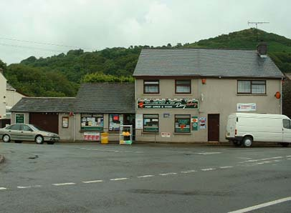
The crime

Paddy Byrne’s father started his shop in the 1920’s and it has been serving the local community ever since. In many ways it is the heart of the village- lots of older people visit daily to chat, and get all the news along with their messages.

However, new estates have been built which should have increased business, but the people have cars and prefer to shop in the supermarket. Byrnes has major cash flow problems with suppliers.
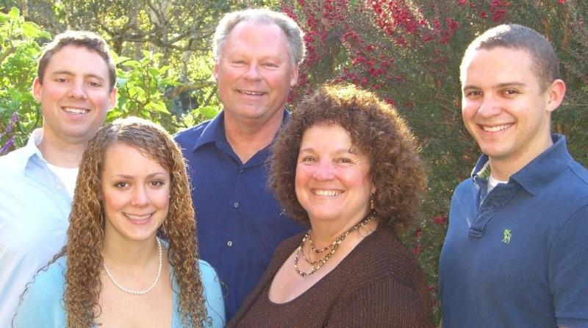
Paddy is now 67 but with his wife passing away 5 years ago he lives over the shop and has no intention of retiring. He still has hopes that one of his 3 children , Eoin, Lorna or Shane will take over the business although they are all now working in Dublin

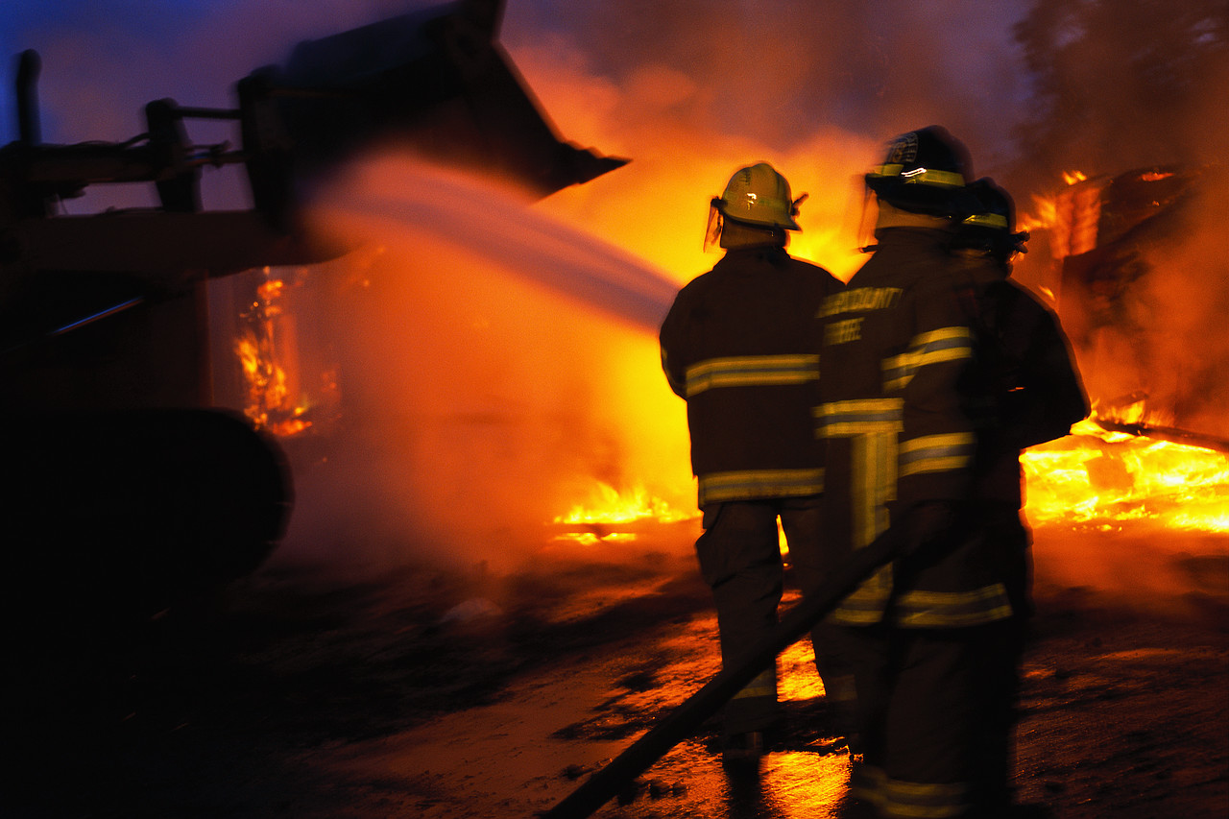
On that day all the family had gathered above the shop for Sunday lunch. Their attempts to persuade their father to consider selling the shop ended in a row- he was determined not to!

Eoin and Lorna left to return to Dublin at around 4 pm, Shane about an hour later.

At 6pm a neighbour noticed smoke in the shop and alerted Paddy who escaped unharmed.
The fire brigade was called but the shop and house were destroyed.

What you need to know!
At the scene of a fire there will be many molecules. To gain useful information the molecules need to be 1. Separated into different substances ( Gas chromatography)
2. Identified ( Mass spectrometry)

What you need to do to solve the crime!

The gardai have called in Forensics to investigate the cause of the fire which is not immediately obvious.
The shop was well insured and so the Insurance company also have an interest

Eoin, Lorna and Shane returned immediately and were interviewed. Items they had with them which could possibly act as a fire accelerant are shown below.
Lorna
Nail varnish remover
contains propanone
CH₃.CO.CH₃
Perfume
contains ethyl ethanoate
CH₃.COO.CH₂.CH₃
Eoin
Windscreen deicer
contains propanol
CH₃.CHOH.CH₃

Shane
Cigarette lighter
contains butane
CH₃.CH₂.CH₂.CH₃

- Use your knowledge of GC-MS to identify A, B, C and D
- Use your knowledge of GC-MS to identify the traces E and F found at the scene of the fire.
- Use what you have discovered to answer the questions below!

What have you found out?

1. What identification did you make of the samples A, B, C and D?
A = …………………………………… B= ………………………………….
C= …………………………………… D = …………………………………

2. Traces of what accelerants were found at the scene of the fire?
E = ………………………………… F = ………………………………………..

3. It is a surprising fact that in most fires where an accelerant is used traces are found at the scene of the fire which can be identified using GC-MS. Why is this ‘surprising’? ……………………………………………………………………………….
………………………………………………………………………………………………………………………………………………………………………………………………
4. What does the evidence suggest about the starting of the fire?
………………………………………………………………………………………………………………………………………………………………………………………………
5. What do you think happened?
………………………………………………………………………………………………………………………………………………………………………………………………………………………………………………………………………………………………………………………………………………………………………………………………
6. What other evidence would need to be collected to prove your idea
………………………………………………………………………………………………………………………………………………………………………………………………………………………………………………………………………………………………………………………………………………………………………………………………………………………………………………………………………………………

